Installing Apache on Ubuntu 20.04

Step 1. Sudo apt-get install apache2

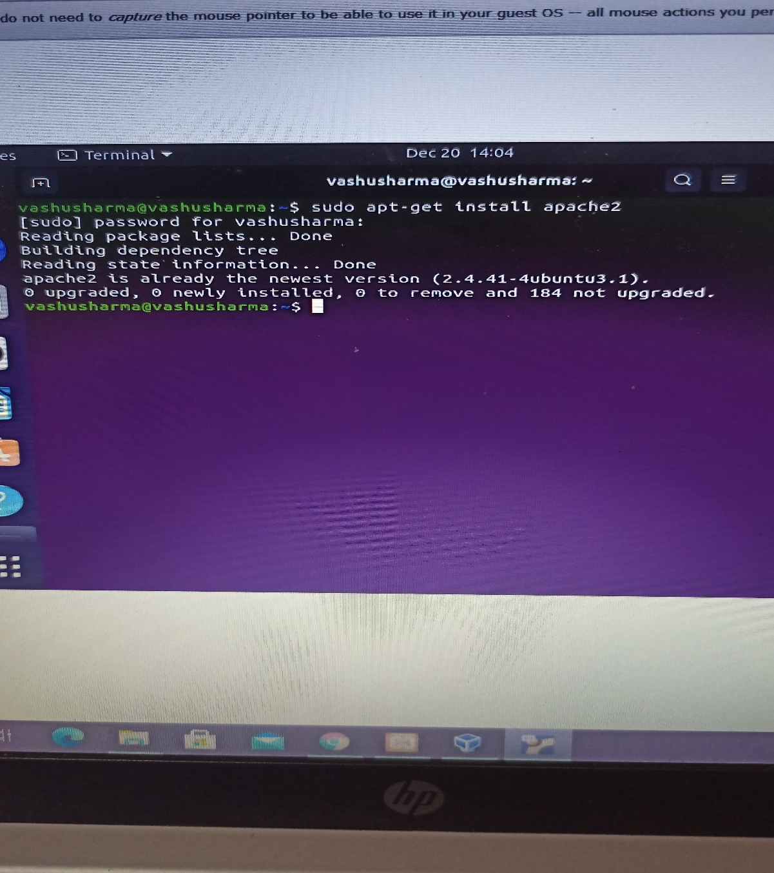

2. sudo systemctl status apache2

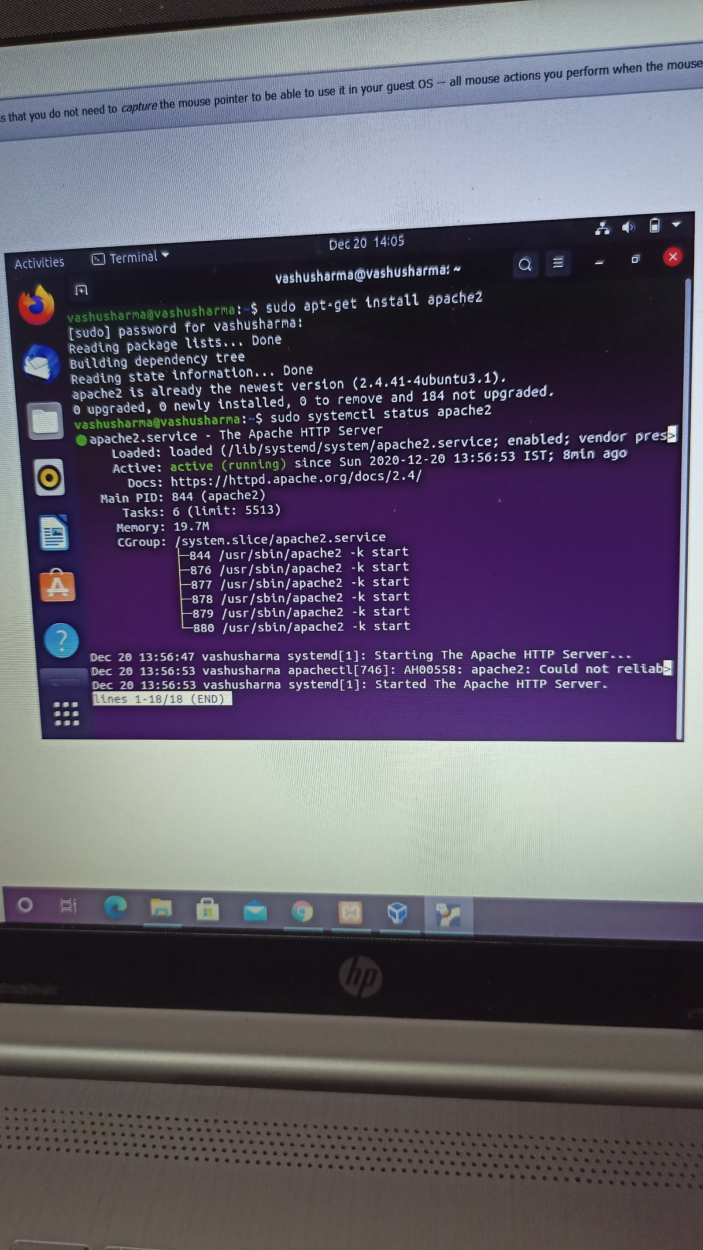

3. Apache2 default page

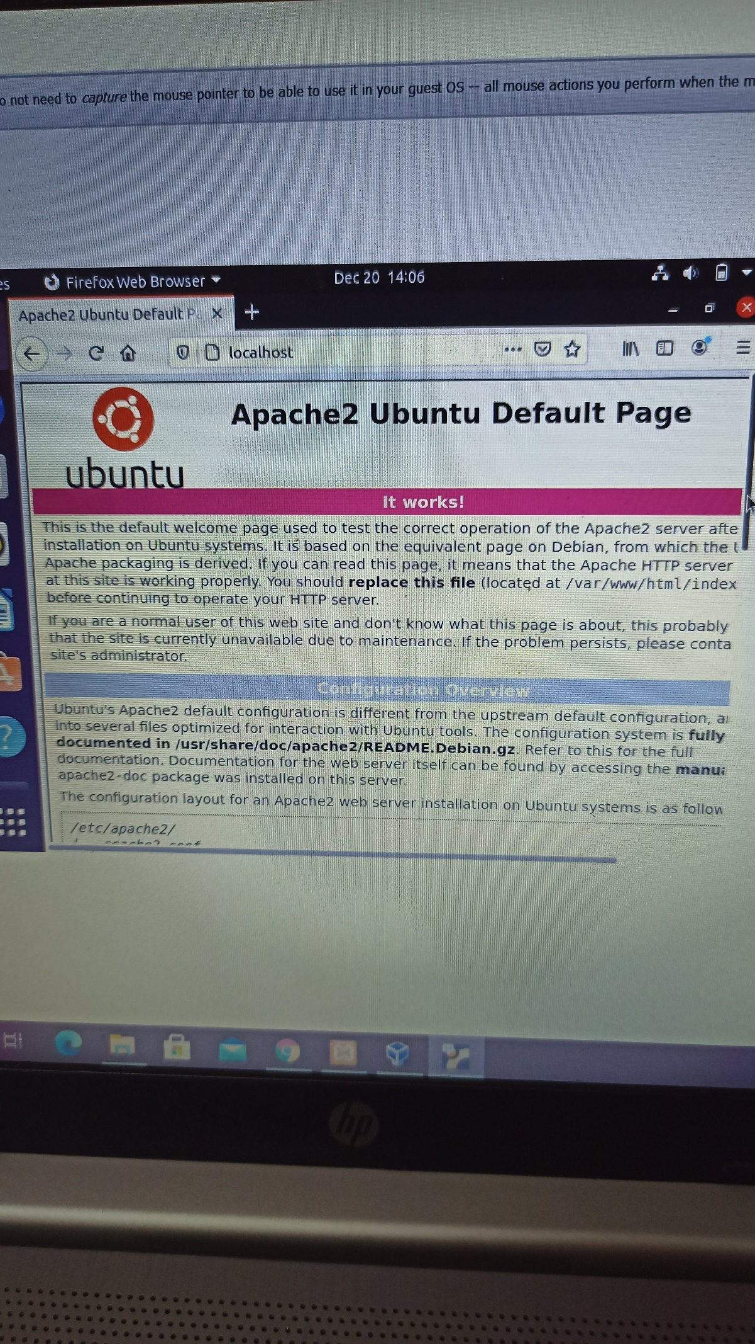

SETTING UP MYSQL SERVER

Step 1. Sudo apt-get Update

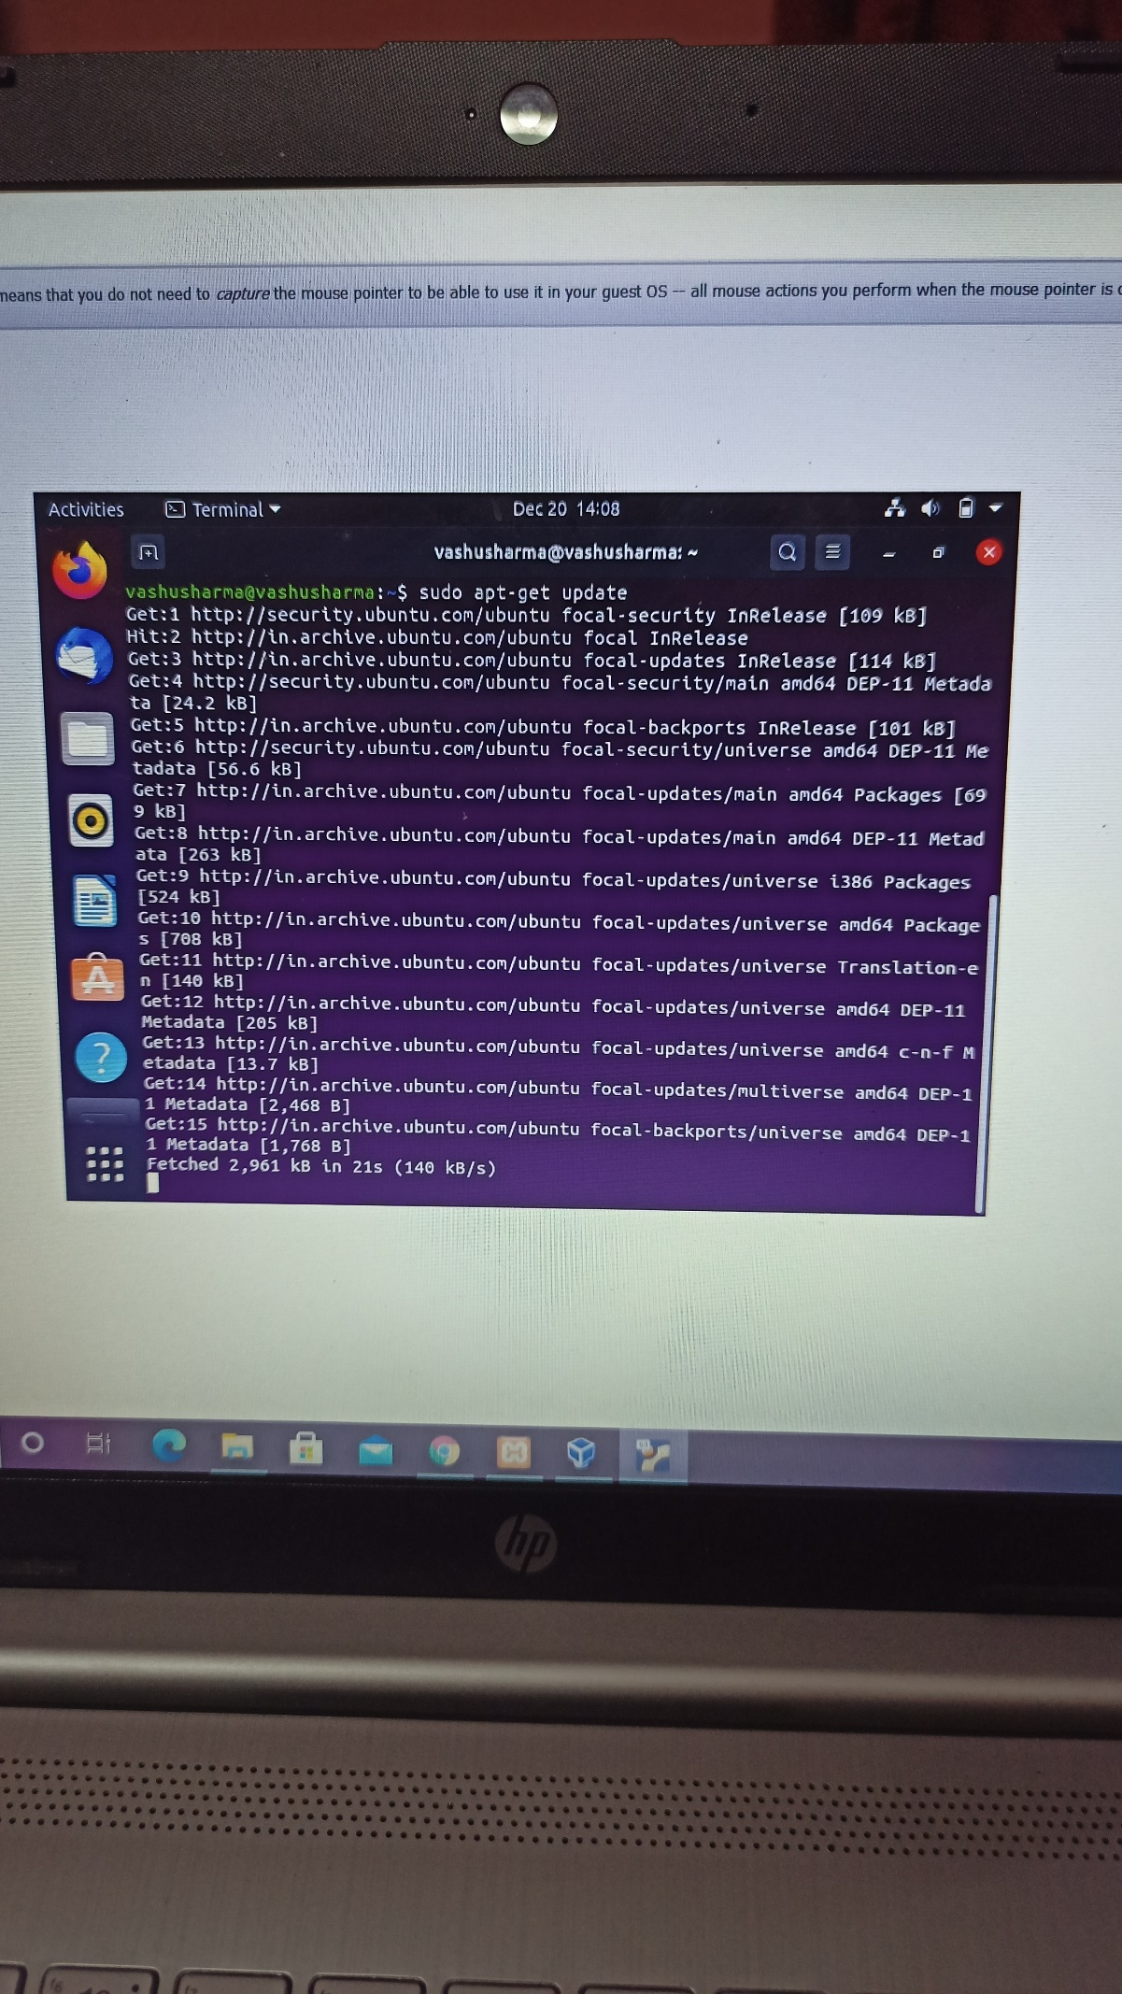

Step 2. Sudo apt-get Install mysql-server

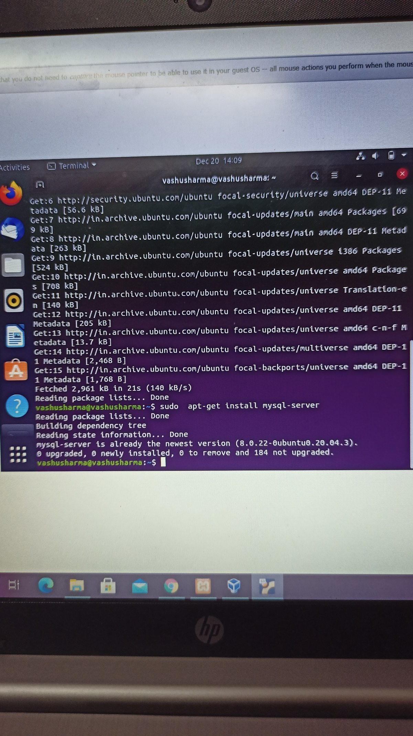

Step 3. Sudo mysql

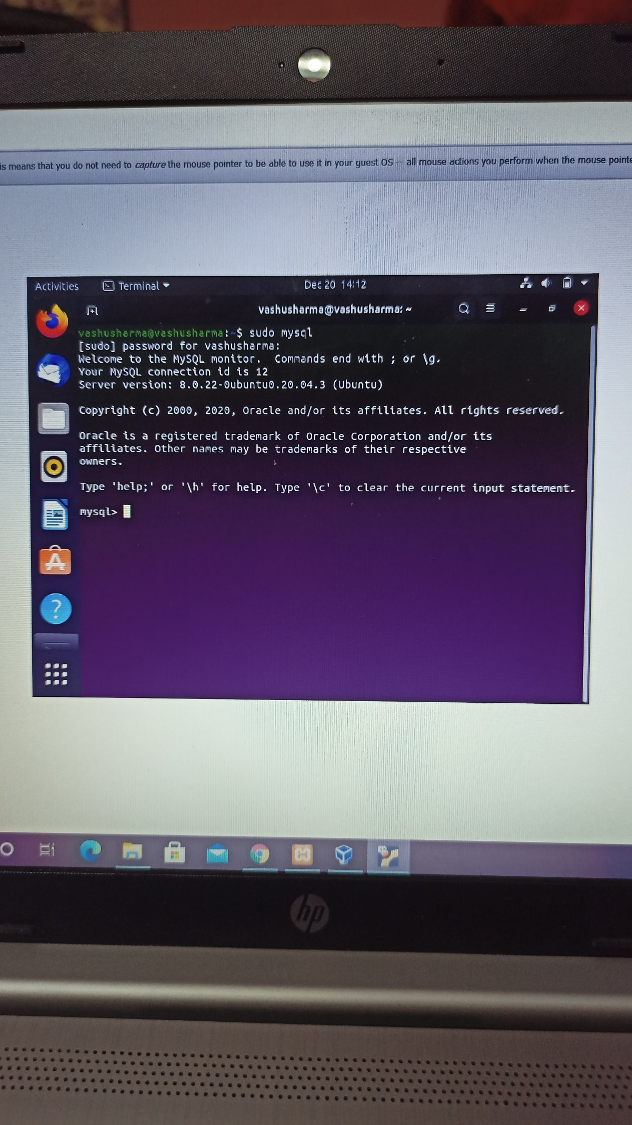

Step 4. Systemctl status mysql.service

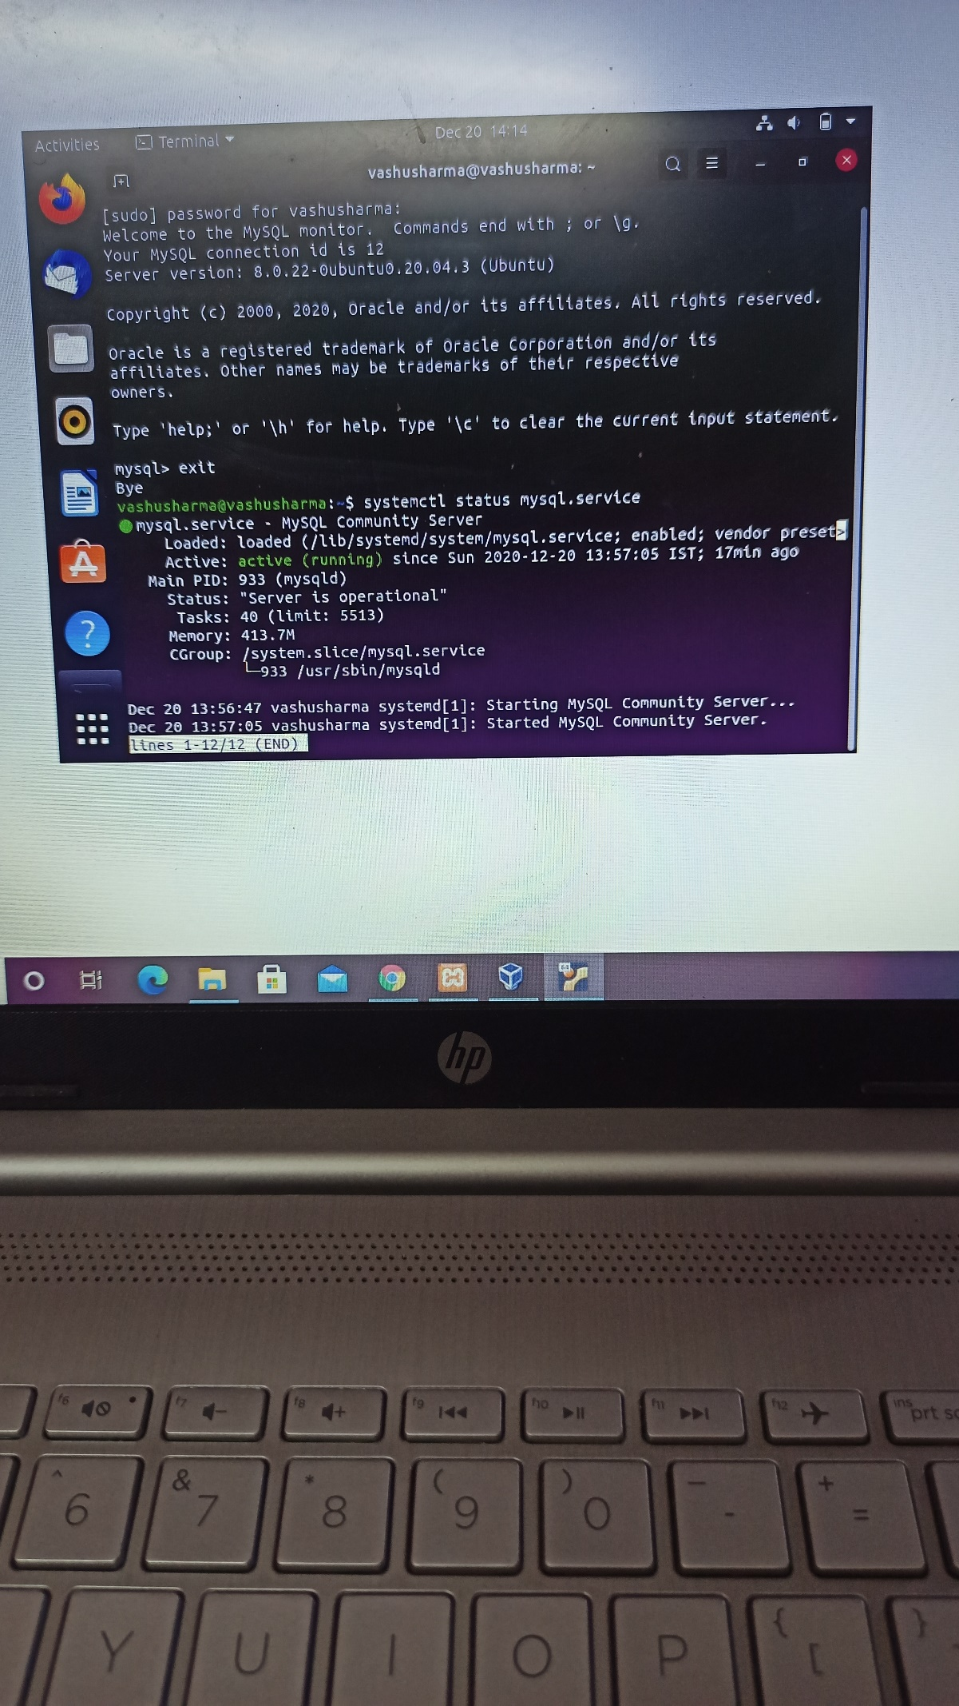

INSTALLING PHP IN UBUNTU 20.04

Step 1. Sudo apt-get Install php

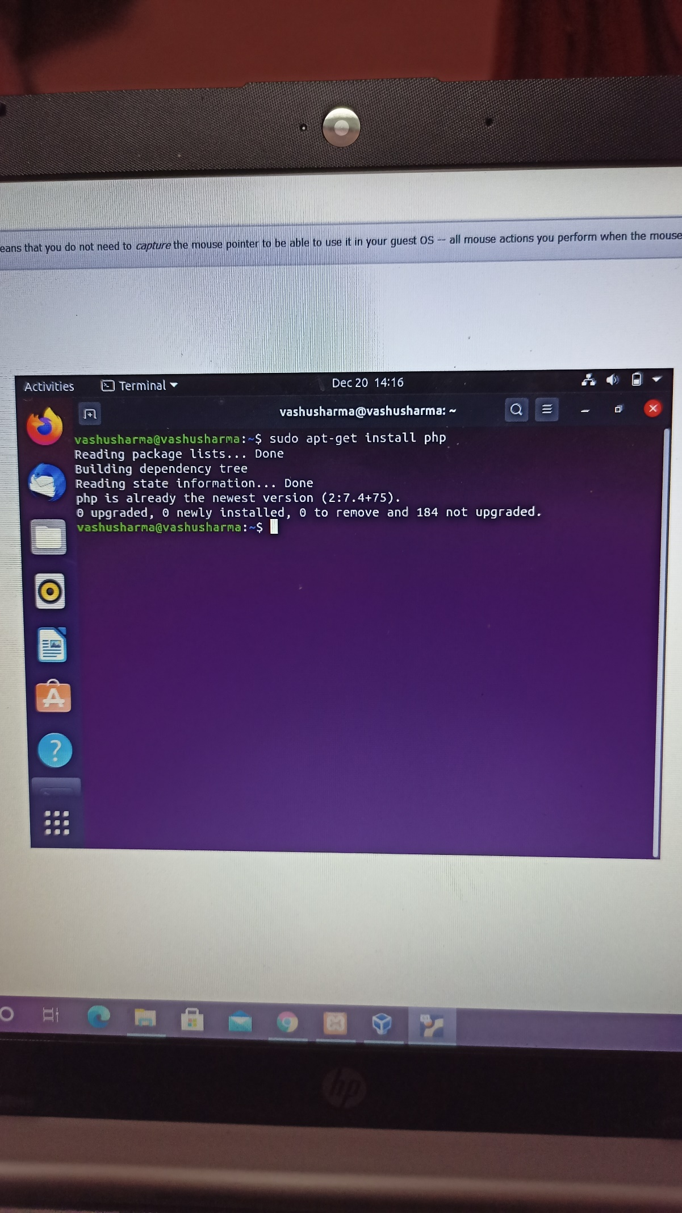

Step 2. Create phpinfo file and write code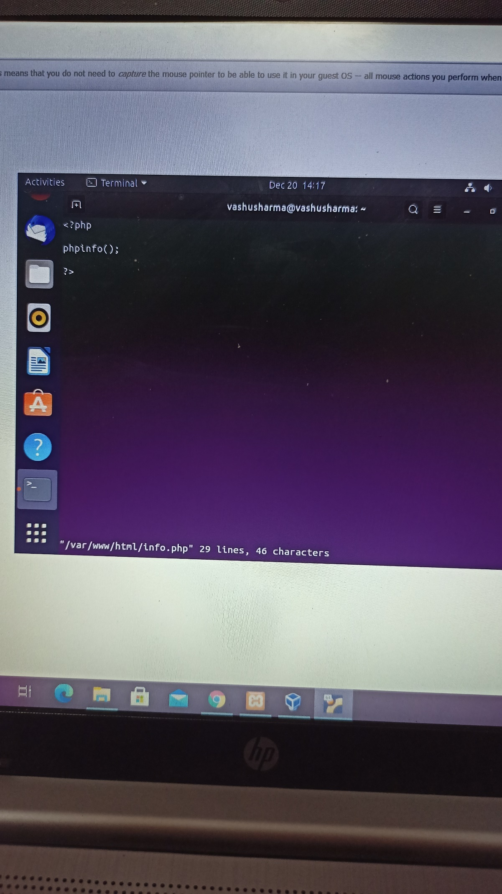

Step 3. Localhost/info.php in browser

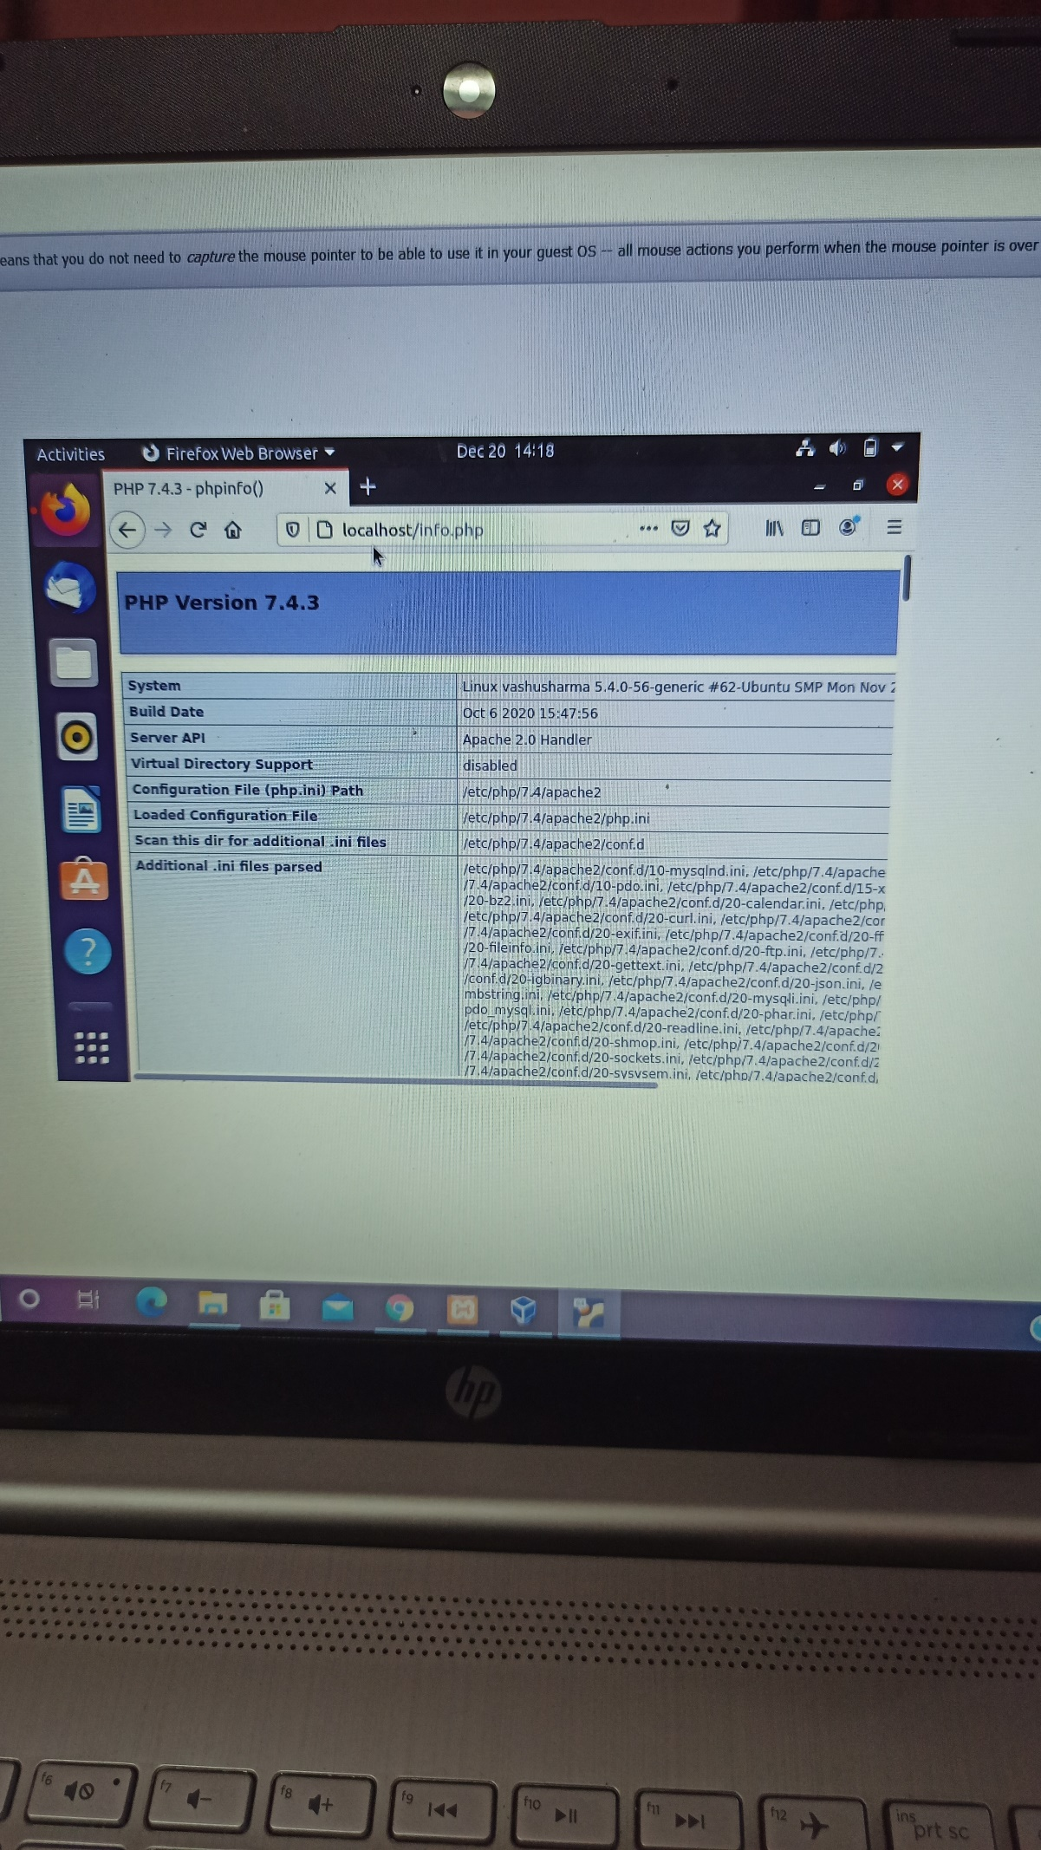

INSTALLING PHPMYADMIN

Step 1. Sudo apt-get install phpmyadmin

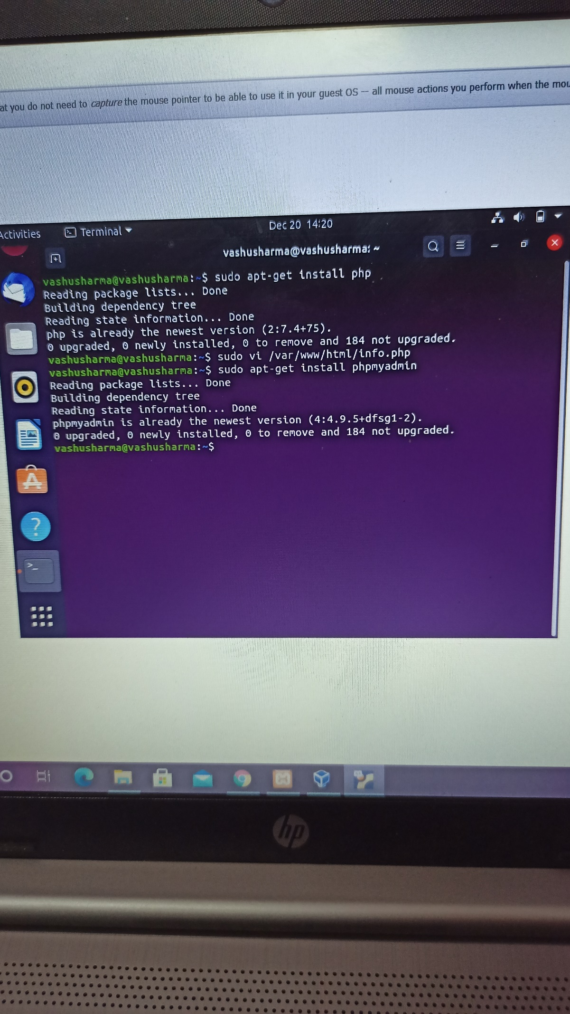

Step 2. Go to browser localhost/phpMyAdmin

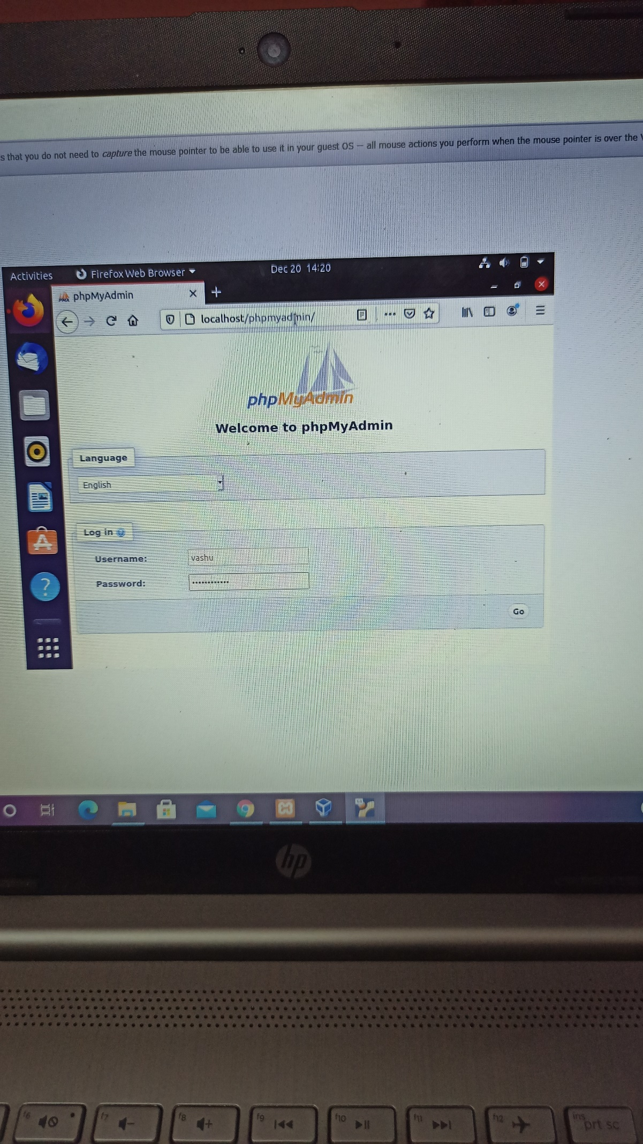

Step 3. LOGIN

